## **Personal Blog on IBM Cloud Static Web Apps**

TEAM MEMBERS:

111421243029 - JEEVAN R

111421243052 - SOLOMON P

111421243053 – SOMANATH M

111421243027- JEBASTIN P

Phase-1 Document Submission

PROJECT: Personal travel blog hosted on IBM Cloud Static Web Apps

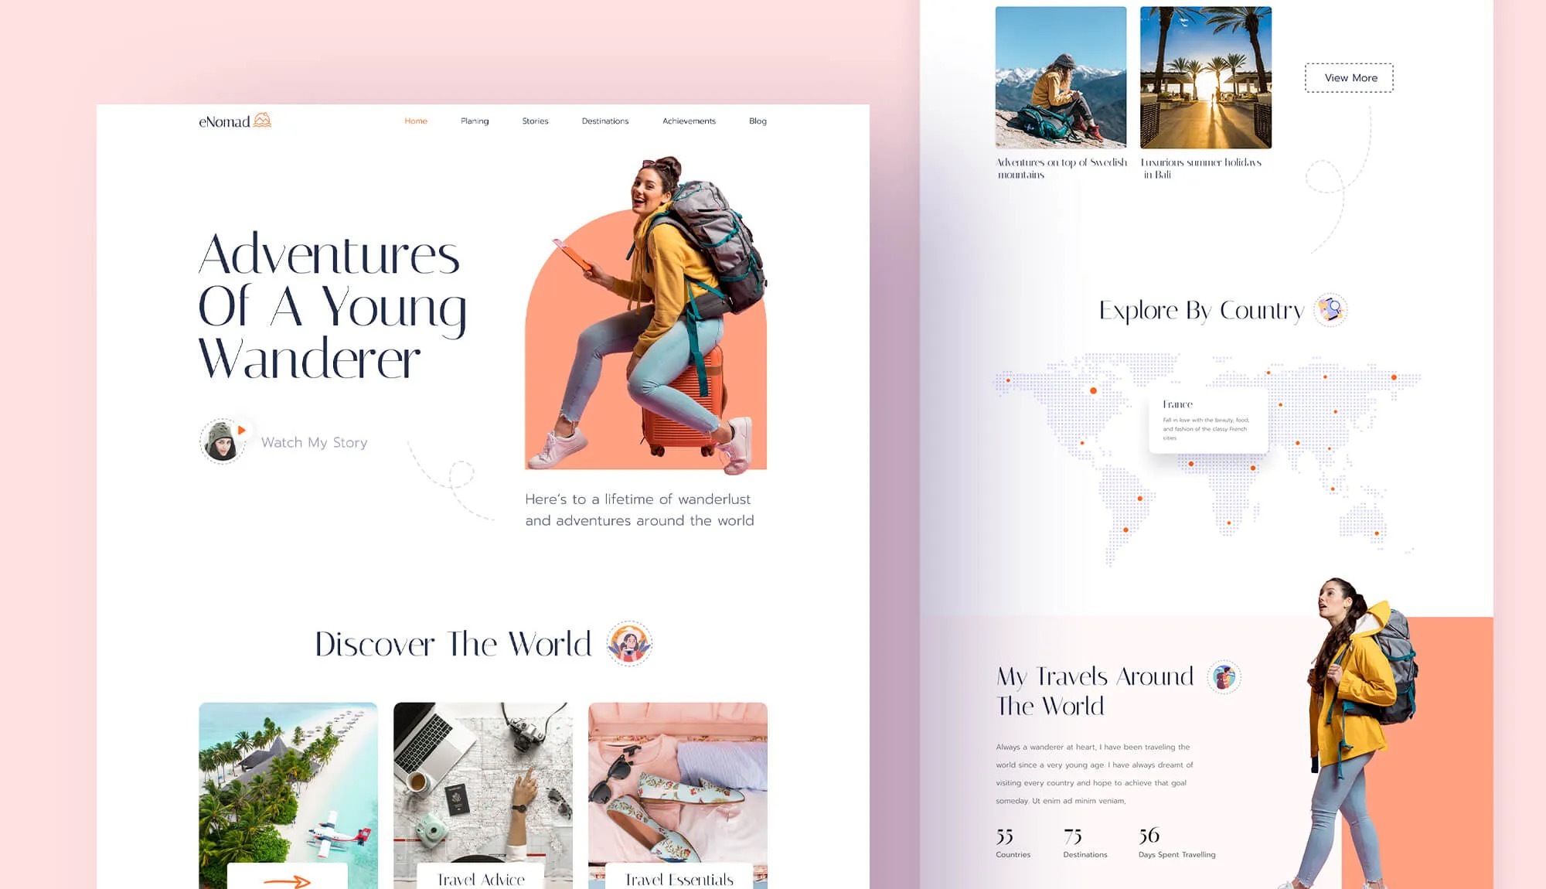

PROBLEM DEFINITION:

The project is to create a personal travel blog hosted on IBM Cloud Static Web Apps. The goal is to share travel adventures, tips, and captivating photos to inspire others to explore the world and create unforgettable memories. This involves designing the blog structure, creating engaging content, setting up the IBM Cloud Static Web Apps, and ensuring ease of updating the blog.

OBJECTIVE:

The objective of this project is to develop and launch a personal travel blog hosted on IBM Cloud Static Web Apps with the aim of inspiring and informing readers about travel adventures, providing valuable tips, and showcasing captivating photos. The project encompasses the following key goals:

1. Design a Structured Blog: Create an organized and visually appealing structure for the travel blog that makes it easy for readers to navigate, discover content, and plan their own adventures effectively.

2. Generate Engaging Content: Produce high-quality written and visual content, including travel stories, destination guides, photography, and personal anecdotes, to captivate and inspire readers.

3. Set Up IBM Cloud Static Web Apps: Utilize IBM Cloud Static Web Apps to host and deploy the blog, ensuring optimal performance, security, and scalability while keeping costs manageable.

4. User-Friendly Maintenance: Implement a user-friendly content management system (CMS) or updating process that allows for easy and regular blog updates, ensuring fresh and relevant content for readers.

By achieving these goals, the project aims to create a travel blog that serves as a source of inspiration and information for travelers, encouraging them to explore the world and create unforgettable memories of their own.

**Design Thinking:**

1. Content Planning: Plan the blog's structure, including sections for travel stories, tips, photos, and possibly a map showing the places visited.
2. Content Creation: Write engaging travel stories, share useful tips, and curate captivating photos from your journeys.
3. Website Design: Design an aesthetically pleasing and user-friendly layout for the blog using HTML, CSS, and possibly JavaScript for interactive elements.
4. IBM Cloud Setup: Set up an account on IBM Cloud and create a Static Web App to host the blog
5. Content Management: Choose a suitable content management system (CMS) or static site generator to make it easy to update and manage the blog.

MODULES:

Module 1: Planning and Design

1. Define Your Blog's Purpose and Audience: Clearly articulate the purpose of your travel blog and identify your target audience to tailor your content accordingly.

2. Choose a Domain Name: Select a memorable and relevant domain name for your blog.

3. Outline Blog Structure: Plan the layout of your blog, including categories, navigation menus, and any additional pages (e.g., About, Contact).

4. Select a Content Management System (CMS): Choose a CMS like WordPress or a static site generator like Jekyll to facilitate content creation and management.

Module 2: Content Creation

5. Create a Content Calendar: Develop a content calendar to schedule and organize your blog posts and content creation efforts.

6. Write Compelling Content: Craft engaging blog posts, travel guides, tips, and personal stories. Incorporate captivating photos and multimedia elements.

7. Optimize Content for SEO: Implement SEO best practices, including keyword research, meta tags, and structured data, to improve search engine visibility.

8. Image Editing: Edit and optimize your travel photos for web use, ensuring fast loading times and high-quality visuals.

Module 3: Setting Up IBM Cloud Static Web Apps

9. Sign Up for IBM Cloud: Create an IBM Cloud account if you don't already have one.

10. Create a Static Web App: Use the IBM Cloud platform to create a new static web app. Define your app's name, select a region, and set up the repository link (e.g., from GitHub).

11. Configure Custom Domain: If you have a custom domain, configure the DNS settings to point to your IBM Cloud Static Web App.

12. Implement SSL/TLS: Set up SSL/TLS certificates to ensure a secure connection for your website.

13. Upload and Deploy Content: Push your blog content and website files to your chosen repository (e.g., GitHub). Configure automatic deployment triggers.

14.Test the Website: Verify that your blog is live and accessible through your custom domain, if applicable.

Module 4: Blog Maintenance and Updates

15. User-Friendly CMS: Ensure that your chosen CMS allows for easy content updates. Train yourself or any contributors on how to use it effectively.

16. Regular Content Updates: Maintain a consistent posting schedule to keep your blog fresh and engaging. Update content as needed.

17. Monitor Website Performance: Use analytics tools to track website traffic, user engagement, and performance. Make improvements based on data insights.

18. Backup and Security: Regularly back up your website data and implement security measures to protect against potential threats.

Module 5: Promotion and Engagement

19. Social Media Integration: Share your blog posts on social media platforms to expand your audience and engage with readers.

20. Email Newsletter: Implement an email newsletter to notify subscribers of new content and updates.

21. Interact with Readers: Respond to comments and engage with your audience through comments, social media, and email.

Module 6: Monetization (Optional)

22. Explore Monetization Options: If desired, research and implement monetization strategies such as affiliate marketing, sponsored content, or selling travel-related products/services.

Module 7: Continuous Improvement

23. Collect Feedback: Encourage readers to provide feedback, and use this input to enhance your blog.

24. Stay Updated: Keep up to date with industry trends, technology advancements, and SEO best practices to continuously improve your blog.

CONCLUSION:

The journey to create a personal travel blog hosted on IBM Cloud Static Web Apps is an exciting and fulfilling endeavor. By following the comprehensive step-by-step module process outlined above, you can embark on a path to share your travel adventures, tips, and captivating photos with the world. This project not only allows you to express your passion for travel but also serves as an inspiration for others to explore the beauty of our planet and create unforgettable memories.

Throughout this project, you'll have the opportunity to design a structured and user-friendly blog, craft compelling content that resonates with your audience, leverage the power of IBM Cloud Static Web Apps for robust hosting and security, and establish a seamless update process to keep your blog fresh and relevant. Moreover, you can explore ways to engage with readers, promote your content through various channels, and even consider monetization options if you wish to turn your passion into a sustainable endeavor.

Remember that the key to a successful travel blog is not just about creating content but also about nurturing a community of fellow travelers and continuously improving your blog based on feedback and industry trends. By embracing this project with dedication and enthusiasm, you'll not only document your own journeys but also inspire countless others to embark on their own adventures and create unforgettable memories of their own. Safe travels and happy blogging!